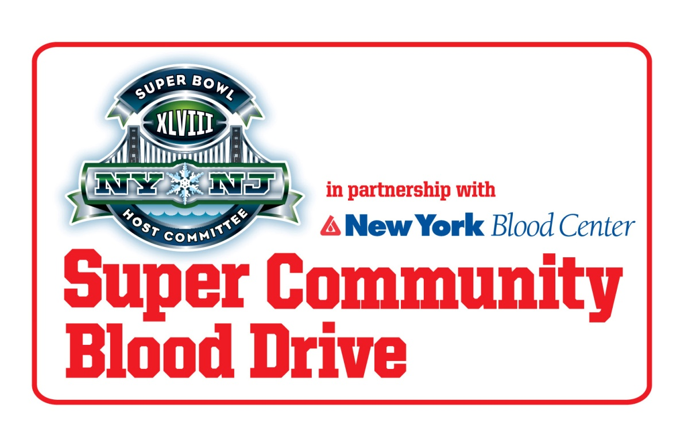

GIVE BLOOD AND JOIN THE WORLD’S BIGGEST HUDDLE!

NYPD Manhattan North 20th Precinct

**Date: Thursday, August 13, 2013**

**Time: 12:00pm – 6:00pm**

**Where:120 West 82nd Street, Muster Room**

**The 2013 Super Bowl Host Committeeis partnering with NYBC to help increase blood donations leading up toSuper Bowl XLVIII.**

**All presenting donors with NYBC between now and January 17, 2014 will be entered into a sweepstakes for one pair of tickets to Super Bowl XLVIII! *(valued at $2,500)***

**The more often you donate, the more times you will be entered.**

NYBC Eligibility Line 1-800-688-0900

NO SS # Required – A Photo or Signature ID Required.

Eat well balanced meals before giving blood.

**To Schedule an Appointment-Please call 1-800-933-2566**

**Walk-ins welcome!**